Stay Calm and Science-on  9/15/2024 | 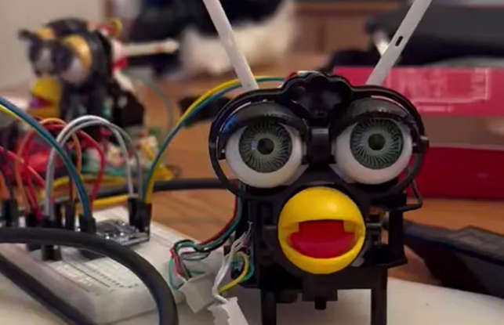

Contents
AI 2
The Seven Wonders of the World according to AI 2
22 Disturbing AI Stories That Should Make Us All Worried (msn.com) 2
Biology and Nature 2
The Entire of Human Evolution - 8 Million Years in 12 Minutes 2
Self-medicating gorillas and traditional healers provide clues for new drug discovery | ScienceDaily 2
COVID 2
Why did some people never get Covid? 2
Earth 2
The Milankovitch Cycle Timeline: Where are we now? 2
Energy 3
Smart Grids: The power is in your hands 3
Psychology 3
Richard Dawkins shares chilling mental health warning 3
OTHER A few websites of interest 3
Lifeology | The place where science and art converge 3
Science writing 3
Search the Databases | Dr. Duke's Phytochemical and Ethnobotanical Databases 3

AI
The Seven Wonders of the World according to AI
AI brings back to life the Seven Wonders of the Ancient World - Neos Kosmos
Using the imagine generator Midjounrey, AI has been able to reimagine these historic structures in modern society along with tourists.
22 Disturbing AI Stories That Should Make Us All Worried (msn.com)
Furby intends to rule the world?!

Biology and Nature

The Entire of Human Evolution - 8 Million Years in 12 Minutes
https://www.youtube.com/watch?v=ep1hFFiqJvw
Self-medicating gorillas and traditional healers provide clues for new drug discovery | ScienceDaily
The team identified four native plant species that are both consumed by gorillas and used in traditional medicine: the fromager tree (Ceiba pentandra), giant yellow mulberry (Myrianthus arboreus), African teak (Milicia excelsa) and fig trees (Ficus). They tested bark samples of each plant for antibacterial and antioxidant properties and investigated their chemical composition.
COVID
Some people never got Covid.
Some people have never gotten COVID-19. An obscure gene may be why (sciencenews.org)
Only the nose knows!
Earth
The Milankovitch Cycle Timeline: Where are we now?
https://www.youtube.com/watch?v=eB3DJtQZVsw

Energy
Smart Grids: The power is in your hands
https://www.youtube.com/watch?v=liEO2Ks4SCQ
Psychology
Richard Dawkins shares chilling mental health warning
https://www.youtube.com/watch?v=d8dDGc2WNJw
OTHER
A couple websites that may be of interest
Lifeology | The place where science and art converge
Science writing : Home - The Open Notebook
Search the Databases | Dr. Duke's Phytochemical and Ethnobotanical Databases (usda.gov)

NOTES:
o Science-on will start at 7PM, July 21, 2024 and we will use the Google Meet platform to meet.
o I will send an email from Google Meet about 10 Minutes before the meeting. So “Around 7..a little before” you will get an email with something to click on.
o ***Please be sure your microphone and camera are on before you click on the Google Meet invite.

RULES:
o Although this is science and that means facts are inherent…We will probably not all agree on everything but we all must be respectful. So the one rule we should uphold is that discussion is great and passion is too, but if the heat gets too hot while we are talking and goes in the direction of blustering name calling or similar --well…we will have to stop that discussion.
o Also along the lines of respectfulness…If you provide a topic but cannot attend we will hold off on discussing until you are there.

