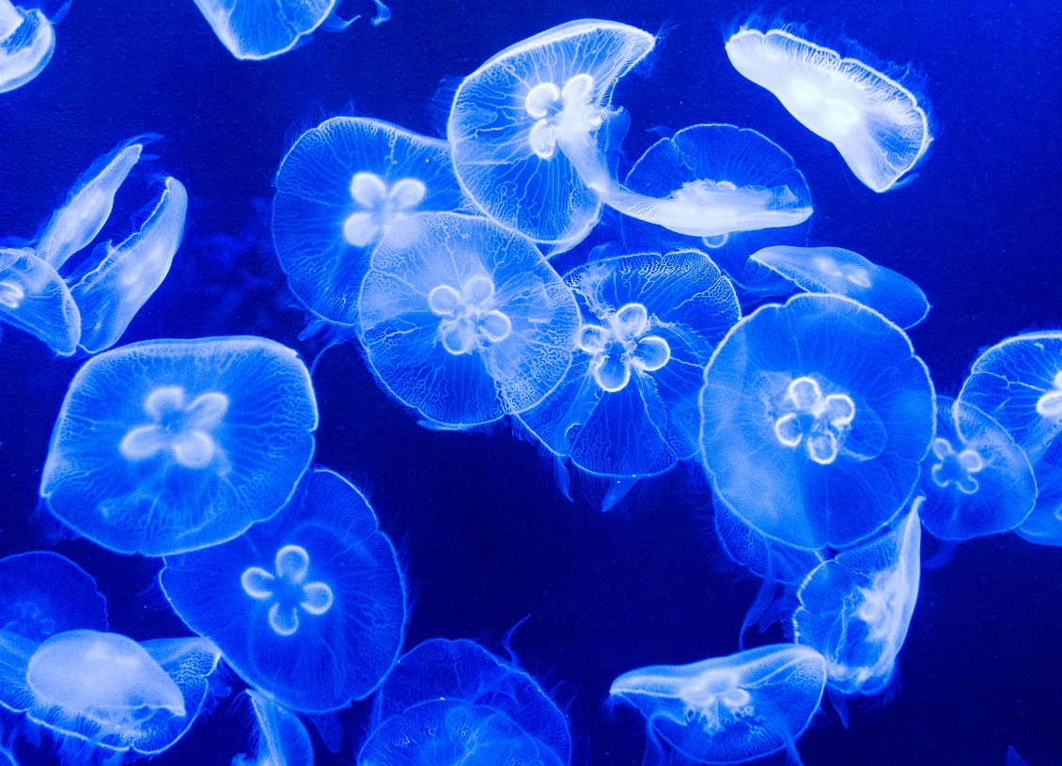

Stay Calm and Science On: Sunday January 19, 2025

**Contents**

**FUN** 2

**BLAME CANADA** 2

**How Often Do You Really Need to Shower? (Sponsored by Mando and Lume)** 2

**SCIENCE AND MEDICINE** 2

**Treatment cure? for ALS features work by Michael Strong.** 2

**Drinking green tea linked to fewer white matter lesions in brains of older adults** 2

**Worst Science Experiments Gone Wrong** 2

**EARTH, SPACE, UNIVERSE** 2

Here’s an interesting Arctic Ocean article. 2

**Scientists Found Signs of a Hidden Structure Inside Earth's Core** 3

**Meteorite strike in Canada caught on home security camera : NPR** 3

**TECHNOLOGY** 3

**Coevolution of AI and society: Study explores opportunities and risks** 3

**”Uniquely Stupid:” Dissecting the Past Decade of American Life | Amanpour and Company** 3

# **FUN**

## **BLAME CANADA**

<https://www.youtube.com/watch?v=bOR38552MJA>

**How Often Do You Really Need to Shower? (Sponsored by Mando and Lume)**<https://www.youtube.com/watch?v=5kq-lcXtB70>  
  
**Is The Universe Able To Think?**[https://www.youtube.com/watch?v=UqIjhcEb-MU](https://na01.safelinks.protection.outlook.com/?url=https%3A%2F%2Fwww.youtube.com%2Fwatch%3Fv%3DUqIjhcEb-MU&data=05%7C02%7C%7C34e0089530db432d83c608dd36f7fa62%7C84df9e7fe9f640afb435aaaaaaaaaaaa%7C1%7C0%7C638727160888962326%7CUnknown%7CTWFpbGZsb3d8eyJFbXB0eU1hcGkiOnRydWUsIlYiOiIwLjAuMDAwMCIsIlAiOiJXaW4zMiIsIkFOIjoiTWFpbCIsIldUIjoyfQ%3D%3D%7C0%7C%7C%7C&sdata=p6ewZIDGNUnwAK6Y3w98Y0JGgb7oR0TlJeLFeQbuDyY%3D&reserved=0)  
  
**Strangest Mysteries Found in Nature**[https://www.youtube.com/watch?v=BPK84N-xaqc](https://na01.safelinks.protection.outlook.com/?url=https%3A%2F%2Fwww.youtube.com%2Fwatch%3Fv%3DBPK84N-xaqc&data=05%7C02%7C%7C34e0089530db432d83c608dd36f7fa62%7C84df9e7fe9f640afb435aaaaaaaaaaaa%7C1%7C0%7C638727160888973886%7CUnknown%7CTWFpbGZsb3d8eyJFbXB0eU1hcGkiOnRydWUsIlYiOiIwLjAuMDAwMCIsIlAiOiJXaW4zMiIsIkFOIjoiTWFpbCIsIldUIjoyfQ%3D%3D%7C0%7C%7C%7C&sdata=M09t5rhCqx41ZTj23Iia%2FJuDWi%2FfISHSCPYswmF%2B%2BQo%3D&reserved=0)

Immortal Jellyfish, Norway’s Hessdalen Lights, Dancing forests

# **SCIENCE AND MEDICINE**

## **Treatment cure? for ALS features work by Michael Strong.**

<https://www.youtube.com/watch?v=ybgecFtOpAE>

Also from the same lab: [Mitigation of TDP-43 toxic phenotype by an RGNEF fragment in amyotrophic lateral sclerosis models - PubMed](https://pubmed.ncbi.nlm.nih.gov/38739752/)

## [**Drinking green tea linked to fewer white matter lesions in brains of older adults**](https://na01.safelinks.protection.outlook.com/?url=https%3A%2F%2Fmedicalxpress.com%2Fnews%2F2025-01-green-tea-linked-white-lesions.html&data=05%7C02%7C%7C34e0089530db432d83c608dd36f7fa62%7C84df9e7fe9f640afb435aaaaaaaaaaaa%7C1%7C0%7C638727160889025490%7CUnknown%7CTWFpbGZsb3d8eyJFbXB0eU1hcGkiOnRydWUsIlYiOiIwLjAuMDAwMCIsIlAiOiJXaW4zMiIsIkFOIjoiTWFpbCIsIldUIjoyfQ%3D%3D%7C0%7C%7C%7C&sdata=JutlWx47gpP6jIhlypKB%2FoBVBOb0%2BdIcPRAPfEmHaos%3D&reserved=0)

Higher green tea consumption is linked to fewer cerebral white matter lesions in older adults without dementia, suggesting potential brain health benefits. Drinking 600 ml of green tea daily was associated with a 3% reduction in white matter lesion volume, while 1,500 ml daily led to a 6% reduction. No significant effects were found for hippocampal or total brain volumes, nor for coffee consumption. The benefits were more pronounced in individuals without depression or the ApoE ε4 allele.

## [**Worst Science Experiments Gone Wrong**](https://www.youtube.com/watch?v=SYnlH2GDcg4)

When an accomplished scientist puts their head in a particle accelerator. (Oops..thought it was turned off)

# **EARTH, SPACE, UNIVERSE**

## Here’s an interesting Arctic Ocean article.

[https://www.threads.net/@mikeachim/post/C76LNZSgcM8](https://na01.safelinks.protection.outlook.com/?url=https%3A%2F%2Fwww.threads.net%2F%40mikeachim%2Fpost%2FC76LNZSgcM8&data=05%7C02%7C%7C654281c2679f473391b708dd370fb077%7C84df9e7fe9f640afb435aaaaaaaaaaaa%7C1%7C0%7C638727262704431444%7CUnknown%7CTWFpbGZsb3d8eyJFbXB0eU1hcGkiOnRydWUsIlYiOiIwLjAuMDAwMCIsIlAiOiJXaW4zMiIsIkFOIjoiTWFpbCIsIldUIjoyfQ%3D%3D%7C0%7C%7C%7C&sdata=zijtFlp8oYDz1G%2F9xfZk5QkxRIIUhs5G%2FuV3%2Fflx%2BAE%3D&reserved=0)

## [**Scientists Found Signs of a Hidden Structure Inside Earth's Core**](https://na01.safelinks.protection.outlook.com/?url=https%3A%2F%2Fwww.sciencealert.com%2Fscientists-found-signs-of-a-hidden-structure-inside-earths-core&data=05%7C02%7C%7C34e0089530db432d83c608dd36f7fa62%7C84df9e7fe9f640afb435aaaaaaaaaaaa%7C1%7C0%7C638727160889011794%7CUnknown%7CTWFpbGZsb3d8eyJFbXB0eU1hcGkiOnRydWUsIlYiOiIwLjAuMDAwMCIsIlAiOiJXaW4zMiIsIkFOIjoiTWFpbCIsIldUIjoyfQ%3D%3D%7C0%7C%7C%7C&sdata=x6Wy2omsOOKAcwuSpII9tujUjEiysY1N1XKe3VZ%2BD%2BI%3D&reserved=0)

Stephenson and colleagues found evidence Earth's inner core may actually have two distinct layers.

## [**Meteorite strike in Canada caught on home security camera : NPR**](https://www.npr.org/2025/01/16/nx-s1-5259837/meteorite-strike-sound-canada-home-security-camera)

# **TECHNOLOGY**

## [**Coevolution of AI and society: Study explores opportunities and risks**](https://na01.safelinks.protection.outlook.com/?url=https%3A%2F%2Ftechxplore.com%2Fnews%2F2025-01-coevolution-ai-society-explores-opportunities.html&data=05%7C02%7C%7C34e0089530db432d83c608dd36f7fa62%7C84df9e7fe9f640afb435aaaaaaaaaaaa%7C1%7C0%7C638727160889037673%7CUnknown%7CTWFpbGZsb3d8eyJFbXB0eU1hcGkiOnRydWUsIlYiOiIwLjAuMDAwMCIsIlAiOiJXaW4zMiIsIkFOIjoiTWFpbCIsIldUIjoyfQ%3D%3D%7C0%7C%7C%7C&sdata=bGpJmoTx6hJqCQrqnEgL7xHLDB%2BXOUVrJpd6s85Z%2F%2BY%3D&reserved=0)

**The study introduces a new research field combining AI and complexity science to examine the coevolution of humans and algorithms. It highlights a feedback loop where human choices and AI suggestions mutually influence each other, leading to complex, unpredictable effects. The study calls for an interdisciplinary approach to address challenges like social inequality and AI bias, emphasizing the need for new regulatory tools to manage these interactions responsibly.**

## **”Uniquely Stupid:” Dissecting the Past Decade of American Life | Amanpour and Company**

[**https://www.youtube.com/watch?v=RKRuvKtFvqo**](https://na01.safelinks.protection.outlook.com/?url=https%3A%2F%2Fwww.youtube.com%2Fwatch%3Fv%3DRKRuvKtFvqo&data=05%7C02%7C%7C2ff004dd98da4941cc4b08dd37f165aa%7C84df9e7fe9f640afb435aaaaaaaaaaaa%7C1%7C0%7C638728232164372756%7CUnknown%7CTWFpbGZsb3d8eyJFbXB0eU1hcGkiOnRydWUsIlYiOiIwLjAuMDAwMCIsIlAiOiJXaW4zMiIsIkFOIjoiTWFpbCIsIldUIjoyfQ%3D%3D%7C0%7C%7C%7C&sdata=xgBE2UegFQjRcRot2Jy1Ct8JtineVbpn1jQ8B8KfX6M%3D&reserved=0)

**NOTES:**

o   Science-on will start at 7PM, and will use the Google Meet platform to meet.

o   I will send an email from Google Meet about 10 Minutes before the meeting..so “Around 7..a little before” you will get an email with something to click on.

o   **\*\*\*Please be sure your microphone and camera are on before you click on the Google Meet invite.**

**RULES:**

o   Although this is science and that means facts are inherent…We will probably not all agree on everything but we all must be respectful.  So the one rule we should uphold is that discussion is great and passion is too, but if the heat gets too hot while we are talking and goes in the direction of blustering name calling or similar --well…we will have to stop that discussion.

o   Also along the lines of respectfulness…If you provide a topic but cannot attend we will hold off on discussing until you are there.