Stay Calm and Science On: Sunday April 20, 2025
Contents
SCIENCE AND MATH 1
Learn about perfect numbers! The Oldest Unsolved Problem in Math 1
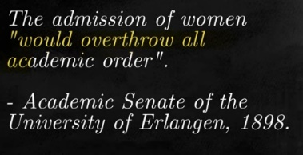The Biggest Misconception In Physics 2
The Most Misunderstood Concept in Physics 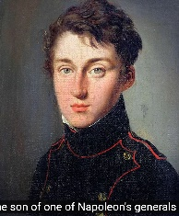(Conservation of energy) 2
AI 2
Ancient Language Decoded by an AI, What It Revealed Is Terrifying 2
FUTURE FROM THE PAST 2
Here are wild things in 2025 predicted in 2002. LOST MEDIA: 2025 Future Living - Technology Predictions from 2002 | Science Channel - YouTube 2
US and OTHER POLITICS 2
Honest Government Ad | Canada 2025 Election 2
And more found here: thejuicemedia | Creating Honest Government Ads | Patreon 2
Is Trump right about the U.S. 'subsidizing' Canada? | About That 2

SCIENCE AND MATH

Learn about perfect numbers! The Oldest Unsolved Problem in Math

The Biggest Misconception In Physics

The Most Misunderstood Concept in Physics (Conservation of energy)

AI

Ancient Language Decoded by an AI, What It Revealed Is Terrifying
https://www.youtube.com/watch?v=0wU2yNGjVDQ

FUTURE FROM THE PAST

Here are wild things in 2025 predicted in 2002. LOST MEDIA: 2025 Future Living - Technology Predictions from 2002 | Science Channel - YouTube

US and OTHER POLITICS

Honest Government Ad | Canada 2025 Election

And more found here: thejuicemedia | Creating Honest Government Ads | Patreon

Is Trump right about the U.S. 'subsidizing' Canada? | About That

NOTES:
o Science-on will start at 7PM, and will use the Google Meet platform to meet.
o I will send an email from Google Meet about 10 Minutes before the meeting..so “Around 7..a little before” you will get an email with something to click on.
o ***Please be sure your microphone and camera are on before you click on the Google Meet invite.

RULES:
o Although this is science and that means facts are inherent…We will probably not all agree on everything but we all must be respectful. So the one rule we should uphold is that discussion is great and passion is too, but if the heat gets too hot while we are talking and goes in the direction of blustering name calling or similar --well…we will have to stop that discussion.
o Also along the lines of respectfulness…If you provide a topic but cannot attend we will hold off on discussing until you are there.

