Stay Calm and Science-on  8/18/2024 | 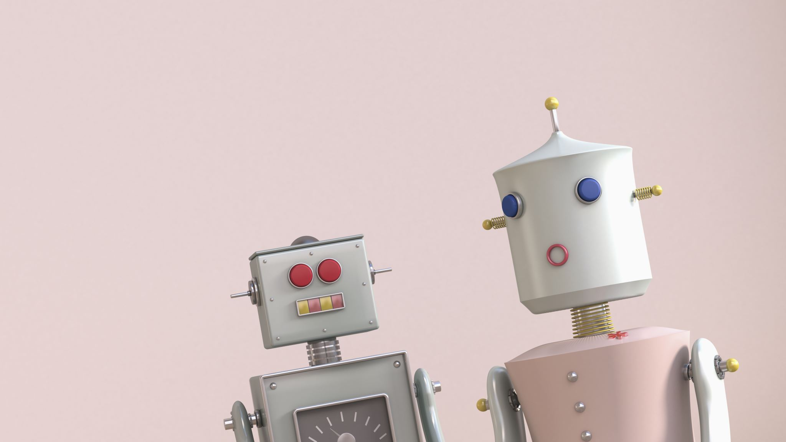

Contents
Biology and Nature 2
Nature's batteries at the bottom of the ocean (13’) 2
Why trees look like rivers and also blood vessels and also lightning…(10’) 2
Photosynthesis has a problem (9’) 2
Psychology 2
How ‘flow state’ can heal trauma (4’) 2
Is there an afterlife? Here’s what he saw while he was ‘dead’ (4’) 2
Medicine 2
Alzheimer's blood tests are getting better, but still have a ways to go (sciencenews.org) 2
Why mpox is a global health emergency — again (sciencenews.org) 2
Other 3
5 New Scientific Discoveries in 2024 (youtube.com) (15’) 3

Biology and Nature
Nature's batteries at the bottom of the ocean (13’)
https://www.youtube.com/watch?v=bGc1Z-BxKXY
Learn about electrolysis of water into hydrogen and oxygen by polymetallic nodules opn the sea bottom.
Polymetallic Nodules. Never heard of them? Well there are trillions of them on the deepest sea beds of our oceans. Mining companies want to scoop them all up for the valuable elements they contain, like manganese, cobalt and nickel. But new research has demonstrated that those metallic constituents are causing a reaction that creates oxygen in the total absence of sunlight or photosynthesis. So...is it really a good idea to remove them?
Why trees look like rivers and also blood vessels and also lightning…
https://www.youtube.com/watch?v=ipj8roHcWnU
Fractals are everywhere!
Photosynthesis has a problem
https://www.youtube.com/watch?v=beROF-QJwoI
Rubisco can bind either CO2 or O2. Learn more here: Photorespiration (article) | Photosynthesis | Khan Academy

Psychology
How ‘flow state’ can heal trauma
https://www.youtube.com/watch?v=5szvutMISsw
PTSD or heartbreak can be overwritten by a flow experience. Skydiving, anyone?
Is there an afterlife? Here’s what he saw while he was ‘dead’
https://www.youtube.com/watch?v=sJs70b2fR3c
Interesting NDE where two people meet!
Medicine

Alzheimer's blood tests are getting better, but still have a ways to go (sciencenews.org)
Decades ago, the only definitive way to get a diagnosis was an autopsy. Since then, scientists have figured out how to see the disease in living people. Spinal taps reveal levels of key proteins associated with the disease. And brain scans can illuminate the characteristic plaques and tangles that mar the brain in a person with Alzheimer’s disease.
Why mpox is a global health emergency — again (sciencenews.org)
A new version of the virus, known as clade Ib, emerged in Congo and has now been confirmed in four neighboring countries. That variant appears to cause more severe cases and may be more transmissible than clade II, which caused the 2022 outbreak that affected mostly men who have sex with men, though the virus also spread to others through contact with skin or infected clothing, bedding or other objects.
Clade Ib is spreading among adults through heterosexual sex, which may become a problem particularly for pregnant women.

Other

5 New Scientific Discoveries in 2024 (youtube.com)
Highlighting 3 of the 5 here:
The discoveries of the Big Ring as well as the Giant Arc are significant as they challenge the Cosmological Principle, which asserts that the universe is homogeneous and isotropic on large scales.
Water Battery: Typically, a large variety of aqueous solutions can be used in place of plain water. This battery type is specifically designed to pollute less (see environmentally friendly claims) due to the lesser use or the absence of heavy metals. Water-activated batteries have been used in radiosondes that shouldn't contain heavy metals since they regularly fall to the ground or ocean surface, and indefinitely remain there.
Cloning: SCNT evolves to clone a rhesus monkey (1 of 113 tries). Scientists in China have cloned the first healthy rhesus monkey, a two-year-old named Retro. Primates have proved particularly difficult to clone, and the scientists overcame years of failure by replacing the cloned cells that would become the placenta with those from a normal embryo.

NOTES:
o Science-on will start at 7PM, July 21, 2024 and we will use the Google Meet platform to meet.
o I will send an email from Google Meet about 10 Minutes before the meeting. So “Around 7..a little before” you will get an email with something to click on.
o ***Please be sure your microphone and camera are on before you click on the Google Meet invite.

RULES:
o Although this is science and that means facts are inherent…We will probably not all agree on everything but we all must be respectful. So the one rule we should uphold is that discussion is great and passion is too, but if the heat gets too hot while we are talking and goes in the direction of blustering name calling or similar --well…we will have to stop that discussion.
o Also along the lines of respectfulness…If you provide a topic but cannot attend we will hold off on discussing until you are there.

