Stay Calm and Science-on

12/15/2024

Contents
INFORMATION 1
Scientific Concepts You're Taught in School Which are Actually Wrong 1
COOL CHEMISTRY 1
Simple chemical reaction that dissolves rust 1
ECONOMICS 1
BRICS countries ditching USD 1
BOTANY 1
Screaming plants 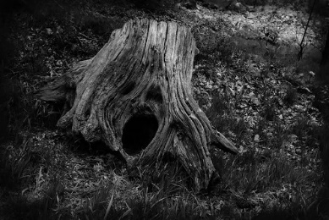 1
GEOLOGY 2
Earth’s inner core may be changing shape 2

INFORMATION

Scientific Concepts You're Taught in School Which are Actually Wrong
https://www.youtube.com/watch?v=0ggzq9V65E8

COOL CHEMISTRY

Simple chemical reaction that dissolves rust
https://www.youtube.com/watch?v=rN6oTXBAmc4

ECONOMICS

BRICS countries ditching USD
https://www.youtube.com/watch?v=kPamBYVbFBw

BOTANY

Screaming plants
Stressed plants make ultrasonic clicking noises
The screams of thirsty plants may prompt some moths to lay eggs elsewhere

GEOLOGY

Earth’s inner core may be changing shape

NOTES:
o Science-on will start at 7PM, July 21, 2024 and we will use the Google Meet platform to meet.
o I will send an email from Google Meet about 10 Minutes before the meeting. So “Around 7..a little before” you will get an email with something to click on.
o ***Please be sure your microphone and camera are on before you click on the Google Meet invite.

RULES:
o Although this is science and that means facts are inherent…We will probably not all agree on everything but we all must be respectful. So the one rule we should uphold is that discussion is great and passion is too, but if the heat gets too hot while we are talking and goes in the direction of blustering name calling or similar --well…we will have to stop that discussion.
o Also along the lines of respectfulness…If you provide a topic but cannot attend we will hold off on discussing until you are there.

